is vs == in Python
Both is and == are comparison operators, but they test very different things. Understanding the difference helps you write correct, bug-free Python.
🔍What's the difference?
is checks identity — are both variables pointing to the exact same object in memory?
== checks equality — do both variables hold the same value?
📋Example 1 — Lists (mutable)
Lists are mutable, so Python creates a separate object for each one:
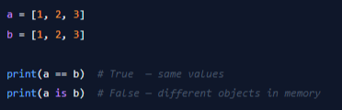
Both lists contain [1, 2, 3], so == returns True. But they live at different memory addresses, so is returns False.
🔤Example 2 — Strings & Integers (immutable)
Python interns small integers and string literals — it reuses the same object:
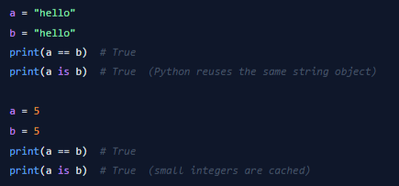

🧩Example 3 — None (from main.py)
There is only ever one None object in Python, so is None is always safe:
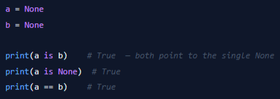
Best practice: Always write x is None (not x == None) to check for None. It's faster, clearer, and can't be accidentally overridden by a custom __eq__.
📌Rule of Thumb
Use == to compare values.
Use is only to check identity — most commonly with None, True, or False.

